AfNOG CHIX 2011, Blantyre, Malawi
Webmail – SquirrelMail Installation

Install SquirrelMail

# cd /usr/ports/mail/squirrelmail
# make install clean

You will be presented with four different configuration screens during installation:
The choices are fine in this screen, so select OK to continue.

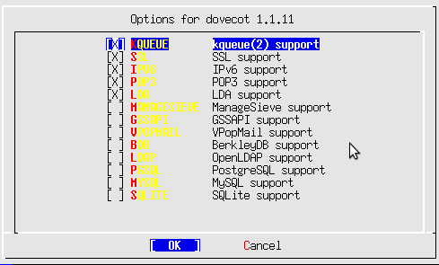

SquirrelMail is written in PHP. You, also, need to install PHP support for Apache. To do this we do:

Select APACHE and then select OK and press enter to continue.

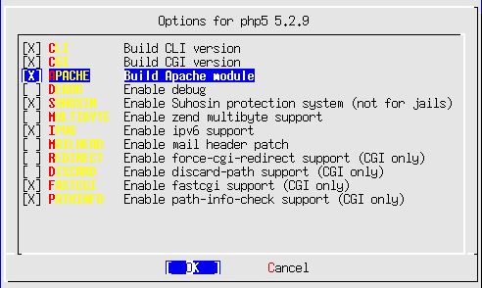

This is already selected and this is fine. Select OK and continue.

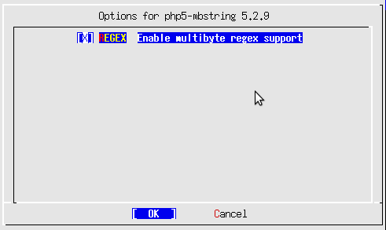

Select the BUNDLED_PCRE option, then OK to continue.

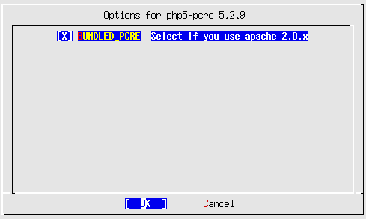

Once SquirrelMail finishes installing you need to configure Apache a bit more by setting up a virtualhost for your mail.

When the installation completes do the following:

# cd /usr/local/etc/apache22
# vi httpd.conf

Look for a section that reads:

<IfModule dir_module>
DirectoryIndex index.html
</IfModule>

and insert the following text right after that line: (watch out for CaMeL case)

<IfModule php5_module>
AddType application/x-httpd-php .php
AddType application/x-httpd-php-source .phps
DirectoryIndex index.html index.htm index.php
</IfModule>

Next, let's edit our php configuration

# cd /usr/local/etc

# cp php.ini-recommended php.ini
# chmod 644 php.ini

We will edit the httpd-vhosts.conf file to do this:

# cd /usr/local/etc/apache22/extra
# vi httpd-vhosts.conf

At the end of the file add the following virtualhost container. (Remember to change the “pcX” entries for your host):

<VirtualHost *:80>
ServerAdmin inst@pcX.afchix.mw
DocumentRoot /usr/local/www/squirrelmail
ServerName webmail.<yourdomain>.afchix.mw
ErrorLog /var/log/mail-error_log
CustomLog /var/log/mail-access_log common
</VirtualHost>

In addition, we must update the main httpd.conf file to give proper permissions to the SquirrelMail install directory:

# cd .. (you should be in /usr/local/etc/apache22)
# vi httpd.conf

Find the end of the entry that starts with:

<Directory "/usr/local/www/share">

and ends with:

</Directory>

After this point in the file add the following:

<Directory "/usr/local/www/squirrelmail">
Options Indexes FollowSymLinks
AllowOverride None
Order allow,deny
Allow from all
</Directory>

Now we stop and start Apache to pick up all our changes.

# apachectl stop
# apachectl start

Final Configuration

At the end of the SquirrelMail installation there was a message on the screen about configuring the application. To do this you would do the next two commands. However, please note that the default configuration is good enough to see our initial SquirrelMail screens, but may not work to actually send email at this point:

# cd /usr/local/www/squirrelmail/
# ./configure

Here is what the initial SquirrelMail configuration menu looks like:

SquirrelMail Configuration : Read: config_default.php (1.4.0)
---------------------------------------------------------
Main Menu --
1. Organization Preferences
2. Server Settings
3. Folder Defaults
4. General Options
5. Themes
6. Address Books
7. Message of the Day (MOTD)
8. Plugins
9. Database
10. Languages

D. Set pre-defined settings for specific IMAP servers

C Turn color on
S Save data
Q Quit

Command >>

You might consider going to the Server Settings option and changing the domain name from example.com to <yourdomain>.afchix.mw

SquirrelMail should now work. You can test this by opening your web browser to the following URL:

http://webmail.<yourdomain>.afchix.mw/

and you should see SquirrelMail up ad running on your host. You can log in to SquirrelMail as the user inst and see what it looks like.

